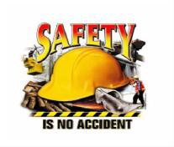
 | Information You Can Use to Prevent Accidents & Injuries
Safe Installation of Drainage Pipe | WHAT ARE THE HAZARDS?  Trench collapse; suspended loads; moving traffic; moving equipment; crushing injuries; lifting; confined space hazards; slips, trips and falls, and accumulation of dangerous gases or vapors.  SAFE WORK PROCEDURES:  Review the safe operating procedures for equipment to be used on the job and perform pre-operational checks.  Determine the type of traffic control setup and assign personnel specific duties.  Park in areas that provide safe entrance and exit of the work area. Don’t create potential conflicts with other vehicles and equipment operating in the work area. Provide maximum protection for workers getting in and out of vehicles.  Wear appropriate personal protective equipment consistent with the hazards, including a pair of good work gloves. Rubber boots may be needed in wet ditches.  At least 48 hours in advance of the work (additional notice is required around legal holidays), contact Call Before You Dig to locate all utilities in and near the work site.  Trench collapses are a major cause of injury and death. Evaluate the work site and follow the OSHA standards and safety precautions for excavation and trenching operations.  Employees on foot must use extreme caution and stay clear of operating equipment. Always establish eye contact with the operator before approaching equipment.  Avoid walking and working under suspended loads. Wear a hard hat when working around backhoes, cranes, and pipe placements.  Use proper lifting techniques. Get help or use a pipe hook, pry bar or other equipment as necessary.  Be aware of escape routes in case of an emergency. It is a good practice to work facing oncoming traffic.  Be aware of loose materials around the trench, tripping hazards, and uneven ground.  Allow ample space for everyone to work safely on site.  Be aware of crushing hazards and pinch points when handling and joining pipe.  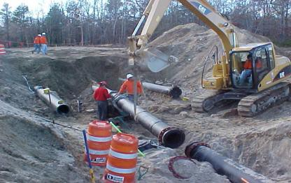  Users of this tailgate talk are advised to determine the suitability of the information as it applies to local situations and work practices and its conformance with applicable laws and regulations.

