Everyday Safety
Tailgate Talks
Portable Generator Safety
This Everyday Safety Tailgate Talk was originally published as part of the May 2018 training
series “The Safety Pins” by Phillip E. Spiezio, Washington County Safety Officer

Portable generators can be a very useful piece of equipment during a power outage. Portable generators can also be very dangerous. If you plan on using a portable generator, it is essential that you take proper precautions for your safety and the safety of those working to restore the power.

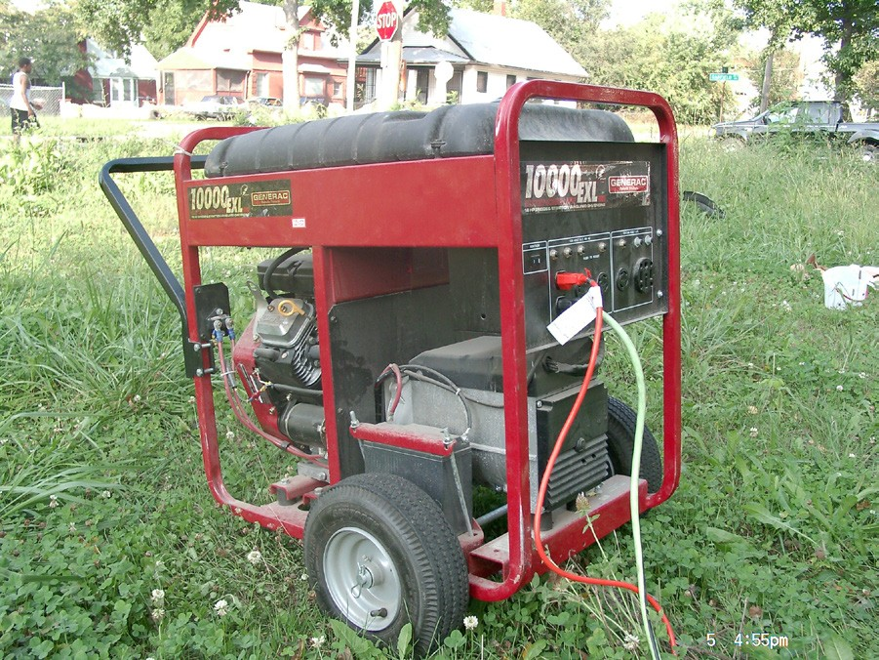
Here are a few tips that will help you use a portable generator safely:
- Always read and follow the manufacturer’s operating instructions before running your generator.
- Generators emit carbon monoxide. Never use your generator inside your home, garage, or any other confined, enclosed area.
- Operate generators away from open windows, vents, or doors.
- Never operate a generator near combustible materials.
- Maintain your generator according to the manufacturer’s maintenance schedule.
- Gasoline vapors are extremely flammable. Allow the generator to cool at least a few minutes
before attempting to refuel.
- Never plug your generator directly into your home outlet. If you are connecting a generator to your home electrical system, be sure to install a power transfer switch.
- If you have to use extension cords, be sure that they are the grounded type and are rated for
the specific application.
- Coiled electrical cords can get extremely hot; always uncoil cords and lay them in flat open areas.
- Generators produce powerful voltage – Take precautions to protect your generator from exposure to rain and snow.
- Use caution - Be sure to not overload your generator.

Everyday Safety Tailgate Talks are published by the Cornell Local Roads Program in cooperation with the National Local Technical Assistance Association and participating partner organizations.

Resources and References:
OSHA Portable Generator Grounding Requirements
https://www.osha.gov/OshDoc/data_Hurricane_Facts/grounding_port_generator.html
OSHA Portable Generator Fact Sheet URL
https://www.osha.gov/OshDoc/data_Hurricane_Facts/portable_generator_safety.pdf
OSHA Portable Generator Safety Webpage
https://www.osha.gov/Publications/3277-10N-05-english-06-27-2007.html

Date: / /

“Portable Generator Safety” Sign In Sheet:

Name: Signature:

