VLR SAFETY TAILGATE TALK
Date:
Subject: Lyme Disease

Location (garage, mm, etc…):

Instructions:
Safety Coordinators & Supervisors should use this Tailgate Talk as a guide for discussion during their safety meetings. The primary purpose of the safety meetings is to give crews the opportunity to discuss any safety related concerns they may have.
Once the meeting has concluded, the Presenter should have each employee sign this form.
TGT Presenter:

Name 1.
2.

3.

4.

5.

6.

7.

8.

9.

10.

11.

12.

13.

14.

15.
Where there are deer, you find ticks. Because we live and work among these animals, it’s important to be cautious, not nauseous. The only tick that can transmit this disease by a bite to humans and animals is the deer tick (also known as the black-legged tick). Studies have shown that an infected tick normally cannot begin transmitting this disease until it has been attached to its host for approximately 24-72 hours; your best line of defense is to examine yourself at least once a day and remove any ticks before they become engorged (swollen) with blood.

WHAT IS LYME DISEASE?
Lyme disease is an infection. The infection is transmitted by the bite of black-legged ticks commonly known as deer tick. Lyme disease, which can affect the skin, heart, nerves, or joints, is an infection that can be cured with antibiotic therapy,

WHAT ARE THE SYMPTOMS OF LYME DISEASE?
There are three stages of Lyme disease: early, early disseminated and late Lyme disease.

Symptoms—1st Stage:
The first stage of Lyme disease is called early Lyme disease. Early Lyme disease usually causes one or more of the following symptoms that occur days to weeks after infection:
- Fatigue
- Chills and fever
- Muscle and joint pain
- Headache
- Swollen lymph nodes
- Erythema migrans

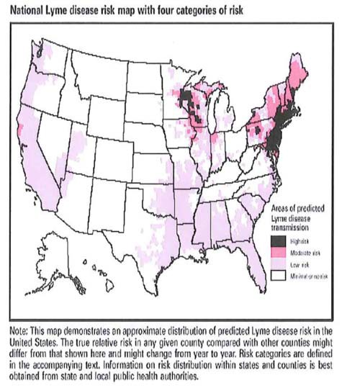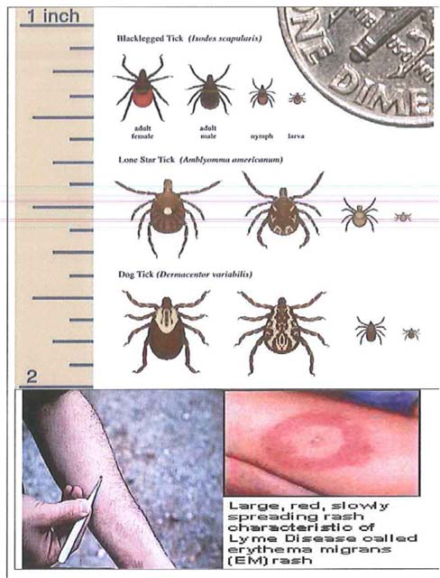
Erythema migrans is the skin rash associated with Lyme disease. This is an expanding rash which usually appears at or near the site of the tick bite. It may appear anywhere from three days to one month after the infected tick’s bite, but it usually appears in about 7 to 14 days. The center of the rash may clear as it grows, giving it the appearance of a bull’s eye. The rash may be warm, but it is usually not painful. The erythema migrans type of skin rash is different from a rash that appears as an allergic reaction to a tick or insect bite. Such reactions to a bite usually appear as redness within hours to one day after a bite, do not grow, and disappear within a day or two.

Symptoms—2nd Stage:
The second stage of Lyme disease is known as early disseminated Lyme disease, which means that the infection is beginning to spread and is affecting certain body functions. This stage occurs weeks to months after the bite of an infected tick. Problems can include:
  - Numbness and pain in arms or legs
  - Paralysis of facial muscles (usually on one side of the face)
  - Meningitis-fever, still neck, and severe headaches
  - Abnormal heart beat (rare)

Symptoms—3rd Stage:
The third stage of Lyme disease is called late disseminated Lyme disease. This stage can occur weeks, months, or even years after infection in untreated patients. Patients with late Lyme disease may get:
  - Chronic Lyme arthritis-brief bouts of pain and swelling usually occurring in one or more of the large joints, especially the knees
  - Nervous system problems, including memory loss and difficulty concentrating
  - Chronic pain in muscles and/or unrest sleep

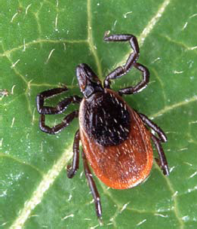

Tick Tips:
Upon returning home, clothes can be spun in the dryer for 20 minutes to kill any unseen ticks.

Deer ticks cannot jump or ﬂy, and do not drop from above onto a potential host. We get ticks by direct contact.

Use tweezers to remove ticks.

Use tick and insect repellents containing DEET or Permethrin to help protect against Lyme disease. DEET‐containing preparations should be used sparingly, not applied to face or hands, and should not exceed 10% concentrations for children over 3 years of age and 30% for adults. DEET should not be used on infants or children under age 3 without ﬁrst consulting your health care provider. Follow the label instructions carefully.

HOW DOES LYME DISEASE SPREAD?
The spirochetes enter the body when an infected tick attaches to the skin to take a blood meal. In order to transmit Lyme disease, the infected tick normally must be attached for approximately 24-72 hours.
Not all types of ticks carry Lyme disease. In New England, the black-legged tick is mainly responsible for transmitting the disease. However, not all black-legged ticks carry the spirochete that causes Lyme disease. Most cases of Lyme disease occur in a few highly affected areas.

WHO IS AT RISK OF GETTING LYME DISEASE?
Black-legged ticks live in wooded, brushy and grassy places, including lawns and gardens. A person is more likely to get the disease during the spring and summer because a lot of time is spent outside, often with large amounts of skin exposed.

WHAT IS THE TREATMENT FOR LYME DISEASE?
Early treatment of Lyme disease involves antibiotics and almost always results in a full cure. However, the chances of a complete cure decrease if treatment is delayed.

IS LYME DISEASE PREVENTABLE?
While outdoors, a few simple precautions can reduce your chance of being bitten:
Wear long pants and long-sleeved shirts to minimize skin exposure to ticks.
Tuck your pants into your socks to form a barrier to tick attachment.
Wear light-colored clothing to make ticks on your clothing easier to see.
Check for ticks, looking particularly for what may look like nothing more than a new freckle or speck of dirt.

If you found a tick and believe it bit, now you know the odds of getting sick.

