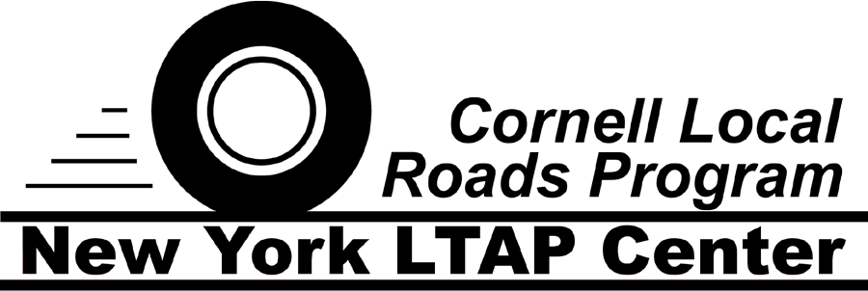
Everyday Safety
Tailgate Talks
Driver Operator Safety
This Everyday Safety Tailgate Talk was originally published as part of the September 2017
training series “The Safety Pins” by Phillip E. Spiezio, Safety Officer of Washington County NY

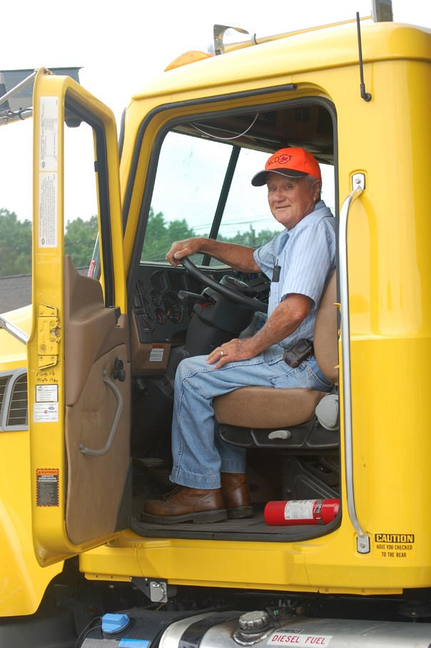
The safety of our worker is the highest priority! The way you drive says much about you and our organization. Make a positive impact by following these work-related safe driving practices:

- Use your seatbelt at all times
- Be well rested, avoid taking medications that make you drowsy and never drive while impaired by alcohol or drugs
- Dedicate your full attention to driving. Avoid distractions such as eating, talking or texting on the cell phone
- Drive safely per the road conditions – drive the speed limit or slower….
- Continually search the roadway or job site to be alert for situations requiring quick action
- Keep your cool in traffic
- Drive defensively. Be seen - Turn on your lights in low light
- Be patient and courteous to other drivers
- Follow only one spotter or signaler
- No matter how difficult, do not take other driver’s actions personally
- Never become complacent
- Expect the unexpected
- Always be sure your truck/equipment is in safe condition
- Always be sure your truck/equipment is safely loaded
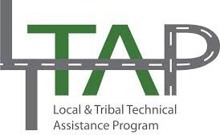

Everyday Safety Tailgate Talks are published by the Cornell Local Roads Program in cooperation with the National Local Technical Assistance Association and participating partner organizations.

Action Item:

Related Topics:

Resources and References:

Date: / /

“Driver Operator Safety Tailgate Talk” Sign In Sheet:

Name: Signature:

