Everyday Safety
Tailgate Talks
Compressed Air Safety
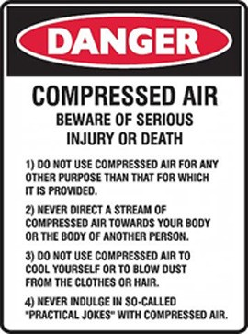
Compressed air is often misjudged and not recognized as a hazard because people think of air as harmless.
- Air forced into body tissues through skin can cause an air embolism (air bubbles in the bloodstream) which can be fatal if it reaches the heart, lungs, or brain.
- Inflation injuries of the intestine can be caused by air being directed at private body areas. A worker in the U.K. died of injuries sustained through horseplay with a compressed air hose. The act of horseplay can be deadly!
- Air blown into the mouth at only 5 PSI can rupture the esophagus or the lungs.
- Eye and ear injuries can occur from a blast of air or flying
particles. These types of eye and ear injuries can cause partial or total loss of sight and hearing.
- The sound from a compressed air hose can reach 120-130 dB which is well above OSHA’s 90dB permissible exposure limit.
- 40 PSI can blow out an ear drum from 4 inches away and possibly cause brain damage.
- As little as 12 PSI can blow an eye out of its socket!
- Flying particles can cause cuts and bruises to any part of the body.
Remember:
- Hoses and lines should be rated to meet the maximum operating pressure of the equipment.
- Always wear proper Personal Protective Equipment:
  - Safety glasses with side shields and a face shield if needed
  - Hearing protection
  - Respiratory protection, depending on the material(s) being worked with

Everyday Safety Tailgate Talks are published by the Cornell Local Roads Program in cooperation with the National Local Technical Assistance Association and participating partner organizations.

- Normal work clothing is not protection against compressed air.
- If you must clean with compressed air, do not use air that is set above 30 PSI. You must
also have effective chip guarding and proper PPE (OSHA standard 1910.242(b)).
- NEVER USE COMPRESSED AIR TO CLEAN CLOTHING OR HAIR!

- NEVER POINT COMPRESSED AIR AT YOURSELF OR ANOTHER PERSON!

Action Item:
Go through the manufacturer’s safety recommendations in the air compressor’s safety manual and read and understand the maintenance requirements for the compressor.

Related Topics:
Resources and References:
VOSHA/OSHA Standards 29CFR1910.135 and 1926.100 for more information Standards are available at http://www.osha.gov/laws-regs.html

Date: / /

“Compressed Air Safety” Sign In Sheet:

Name: Signature:

