VLR SAFETY TAILGATE TALK
Date:
Subject: Working with Cable Clips or Clamps

Location (garage, mm, etc…):

Instructions:
Safety Coordinators & Supervisors should use this Tailgate Talk as a guide for discussion during their safety meetings. The primary purpose of the safety meetings is to give crews the opportunity to discuss any safety related concerns they may have.
Once the meeting has concluded, the Presenter should have each employee sign this form.
TGT Presenter:

Name 1.
2.

3.

4.

5.

6.

7.

8.

9.

10.

11.

12.

13.

14.

15.
There’s only one right way to install cable clips when you want to get the maximum efficiency, up to 85%, out of a prepared loop or thimble‐eye termination. Otherwise the capacity of the termination can be severely reduced, risking the lives of workers and others nearby.
Here’s how to install cable clips correctly:
- Most cable clips have two sections. There’s saddle part and a “U” ‐shaped part. You need the right‐sized clip for the wire rope diameter.
- You need to know the number of clips required, the amount of rope to turn back from the thimble, and the torque needed to tighten the nuts. There are tables to spell out all of this information (see sample below).
- At least three clips should be used when making any prepared loop or thimble‐eye termination for wire rope, especially for hoisting.
- All three clips must be installed with the saddle part on the live end of the rope. This lets the live end rest in the saddle, so it’s not crushed by the “U” part of the clip.
- The “U” goes on the dead end of the rope where crushing will not affect the breaking strength of the hoist line.

Continued.

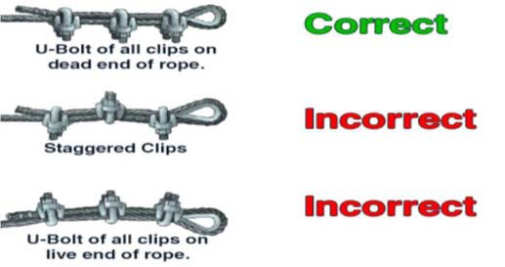
Rope  (inches) | Mini- mum Num- ber  of Clips | Amoun t of  Rope Turn- back from Thim- ble (inches  ) | Torque in  Foot- Pound s for Unlu- bricat ed Bolts
5/16 | 2 | 5 1/2 | 30
3/8 | 2 | 6 1/2 | 45
7/16 | 2 | 7 | 65
1/2 | 3 | 11 1/2 | 65
9/16 | 3 | 12 | 95
5/8 | 3 | 12 | 95
3/4 | 4 | 18 | 130
7/8 | 4 | 19 | 225

