Safety Brief Series

Safety Brief - 2017-1
Updated: December, 2018

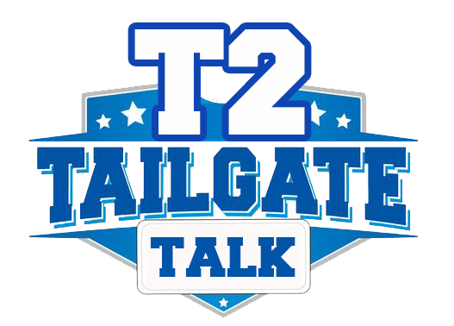
Heavy Equipment
& Heavy Equipment Hazards
General Rules When Heavy Equipment Is Nearby
• Always remain alert to the equipment moving around you.
• Do not get near moving equipment unless necessary.
• Never ride on equipment unless it has been designed to carry you. This means it must have a seat and a seat belt.
• You must stay in the view of the operator. Be aware of blind spots around the vehicle and avoid positioning yourself in
those blind spots. When approaching any equipment, make sure the equipment operator is aware of your presence
before approaching the equipment.
• Keep your head on a swivel! Be aware of constantly moving equipment on the work site.
• Listen for and pay attention to back-up alarms. If you hear a back-up alarm, find out where it is coming from.
• Always wear your hi-visibility gear when working around equipment. Make yourself visible to the equipment operator
as well as traffic.

Rules for Transporting Heavy Equipment
• Inspect all transporting equipment and make sure it is all in good working condition.
• Always provide for the protection of the general public.
• Wear safety shoes.
• Estimate the center of gravity for the equipment to be loaded.
• Always load equipment slowly onto its carrier.
• If equipment is to be driven off-site, make sure the steering, braking, and light systems are in good operating condition.
• Tightly secure the piece of equipment to its carrier.
• Be sure that the boom or any other extensions of the equipment are tightly secured. If working with others, be sure to work as a team.
• Keep your hands dry and as free of grease and oil as possible.
• Always keep the loading area free of debris and unnecessary tools.

Additional Discussion Notes: What does your department do to further protect the general public? For example, use a flagger or barricade the work area.

Remember: A little mistake with heavy equipment can easily become a major accident that causes severe injury or even death.
Guide for Discussion
Heavy equipment is designed to handle very large volumes or heavy loads. Therefore, these are powerful machines that are dangerous to everyone around them if they are not operated correctly. It is important to remember the proper methods used to move them from one site to another and how to work around their operation.

Heavy Equipment Hazards
The use of heavy equipment in a work zone is necessary to the overall success of many projects. However, unauthorized or unwise use of heavy equipment can result in personal injury, loss of life, or property damages. Today we will discuss some key points to keep in mind when working around heavy equipment.

Guide for Discussion
Workers
• Always be alert to the position of the equipment around you and your visibility to equipment around you.
• Only authorized personnel are allowed to operate the equipment.
• Never ride the equipment unless it is designed for it.
• Always keep away from suspended loads.
• When working as a signal person, be aware of all overhead power lines. Keep crane booms at least 10 feet from all power lines.
• Never take naps, breaks, or lunch around heavy equipment.

Equipment Operators
• Be sure that all moveable equipment is either accompanied by a signal person or has an operational back-up alarm.
• Be aware of all overhead power lines and the possible effect on equipment operating within the close vicinity. Keep crane booms at least 10 feet from all power lines.
• Always lock the equipment before it is to be lubricated, adjusted or repaired. Put the key in your pocket, it is your own
personnel Lock-Out system.
• Always replace gears, belts, or any other guards after repair or adjustment.
• Always secure and lock out equipment upon completion of use.
• Be sure to protect the glass areas of cabs with either metal grates or wood covers.

Additional Discussion Notes: Who are the authorized equipment operators in the department? _______________________________________________________________________________.

Remember: The best policy around heavy equipment is to take no chances. Be aware of what is going on around you—both workers and equipment operators.
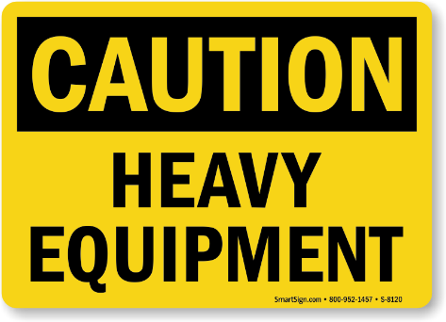

For additional Tailgate Talks, Safety Briefs or more information about the Connecticut Technology Transfer Center, visit us at: www.T2center.uconn.edu

Reprinted with permission from the CT Interlocal Risk Management Agency (CIRMA)

