Everyday Safety
Tailgate Talks
Hand Tool Safety
This Everyday Safety Tailgate Talk was originally published as part of the June 2017 training
series “The Safety Pins” by Phillip E. Spiezio, Washington County Safety Officer
Almost all of us use some sort of hand tool to perform a certain type of task every day. However, the use of tools are a contributing factor to many injuries when used incorrectly.
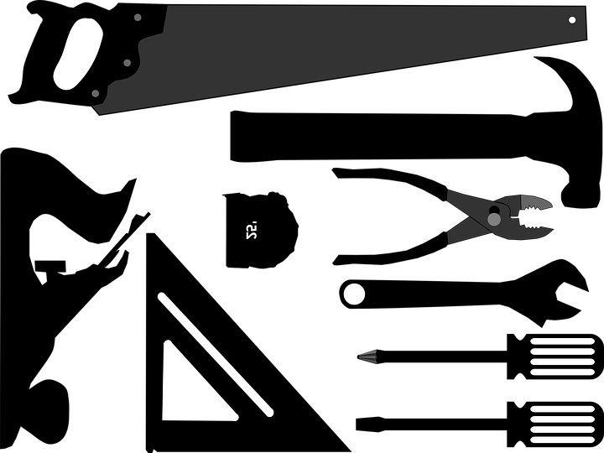
The following are a few helpful tips that will allow you to perform this type of work safely:
- Use the correct tool for the job. A screw driver is not a pry bar!
- Keep tools clean and in good condition.
- Use and maintain power tools according to their instructions.
- Make sure power tools are properly grounded or are double insulated. Never cut off the
ground plug.
- Switch off, unplug, and lockout power tools before servicing the tool, changing blades or
switching out attachments.
- Wear tight fitting clothing - no strings or loose ends to get entangled.
- Wear appropriate personal protective equipment. Safety glasses, protective clothing, face shields, goggles, hearing protection, dust masks, etc.
- Keep bystanders at a safe distance. Do not walk up to someone without obtaining their
attention from a safe distance first.
- Unplug and store tools in a safe place after use.
- Do not place any tools on top of your stepladder because it is too easy to forget they are there when moving it!
Above all else - be sure your brain is engaged before putting your body into motion!!!

Everyday Safety Tailgate Talks are published by the Cornell Local Roads Program in cooperation with the National Local Technical Assistance Association and participating partner organizations.

Action Item:

Related Topics:
- Ladder Safety
Resources and References:

Date: / /

“Hand Tool Safety” Sign In Sheet:

Name: Signature:

