Everyday Safety
Tailgate Talks
Electrical Safety
This Everyday Safety Tailgate Talk was originally published as part of the January 2016
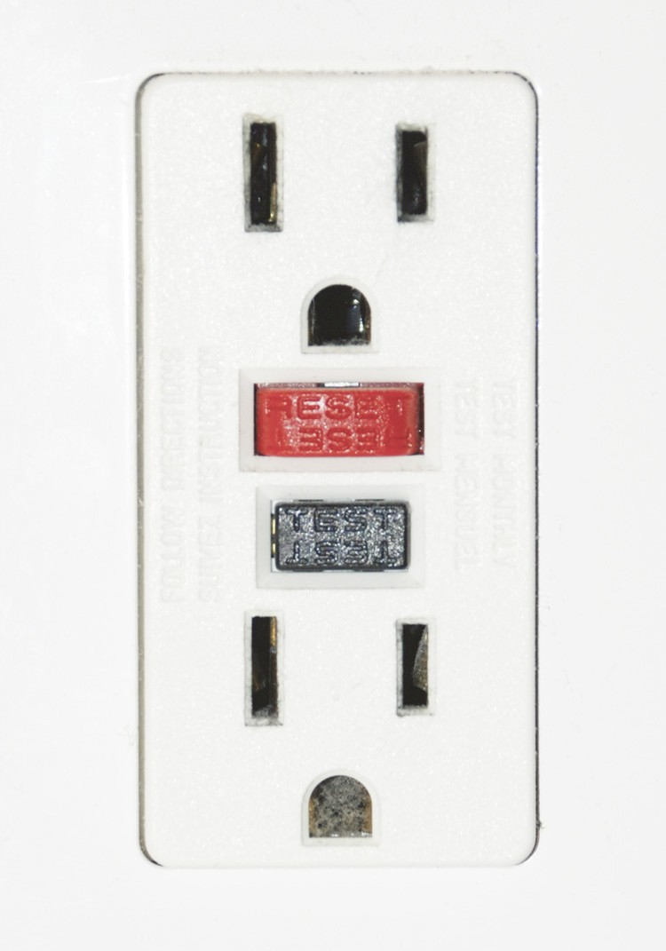
training series “The Safety Pins” by Phillip E. Spiezio, Washington County Safety Officer

Electrical hazards can cause severe burns, shocks, and electrocution if not taken care of properly.

Here are a few safety tips that will help protect you from electrical hazards.
- Never assume that any wire is safe to touch.
- Stay at least 10 feet away from overhead power lines.
- If working at heights or handling long objects, look for electrical wires before starting work.
- Never operate electrical equipment while you are standing in water. In damp areas, use only ground fault circuit interrupter (GFCI) protected equipment.
- Never repair electrical cords or equipment unless you are qualified and authorized
to do so. Do not place electrical tape on a cut in the outer insulation of a lead cord.
- Stay well away from fallen overhead power lines.
- Be sure that electrical outlets in your bathrooms, basement, garage and outdoor areas are all GFCI protected.
- Check GFCI outlets regularly to ensure that they are working correctly
- Always use extreme caution when working around electricity!

Everyday Safety Tailgate Talks are published by the Cornell Local Roads Program in cooperation with the National Local Technical Assistance Association and participating partner organizations.

Action Item:

Related Topics:

Resources and References:
OSHA electrical safety webpage URL:
https://www.osha.gov/SLTC/electrical/

Date: / /

“Electrical Safety” Sign In Sheet:

Name: Signature:

