Everyday Safety
Tailgate Talks
Hazards of Solvents
This Everyday Safety Tailgate Talk was originally published as part of the September 2015 training series “Tailgate Talks” by the Connecticut Transportation Institute Technology Transfer Center
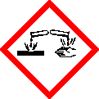
We use solvents practically every day in our lives. At work, we may use or be exposed to solvents when we come in contact with paints, coatings, while using dip tanks, thinners, degreasers, cleaners, glues or mastics. As a result of this widespread usage, it is important to know some of the hazards that are associated with the group of chemicals, generally called “solvents”.
For practical purposes a solvent is simply a liquid capable of dissolving specific solids or liquids. As you know, there are solvents that we use daily that are hazardous. Petroleum based solvents are the most common type used in industry. Therefore, as part of your job, it’s important for you to understand the hazards of working with or around solvents.
Exposure and over-exposure to a solvent can come from various methods. The routes of entry may include:
- Absorption by direct contact on the skin. If there are no “barriers” between the solvent and your skin, the solvent can be absorbed through your skin.
- Inhalation by breathing solvent vapors. Breathing in the solvent vapors can quickly result in the chemical getting into your body and bloodstream via your lungs.
- Ingestion from literally eating the chemical by not practicing good hygiene after handling solvents.
- Direct contact with your hands and mouth through eating or smoking may result in unexpected ingestion of solvents. • Puncture of the skin by a tool or other object which has a coating of solvent. Punctures can result in the direct introduction of toxic chemicals into your body.
- Puncture of the skin by a tool or other object which has a coating of solvent. Punctures can result in the direct introduction of toxic chemicals into your body.

Everyday Safety Tailgate Talks are published by the Cornell Local Roads Program in cooperation with the National Local Technical Assistance Association and participating partner organizations.

Overexposure to solvents can cause a variety of ailments. Depending on the type of solvent you are exposed to, the body will react in different ways. Skin contact may result in minor skin rashes or an allergic reaction resulting in “chlordane”. This happens when the solvent dissolves the skin’s natural oils. Some workers can develop a sensitization to a particular product or chemical. Sensitization results in the entire body being “overly” sensitive to a particular chemical or product. After sensitization has occurred, even a very slight exposure can result in adverse or serious reactions. Serious overexposures can lead to illnesses resulting in organ or tissue damage.
As with any chemical or product, important information is contained in the product’s Safety Data Sheet (SDS). The SDS provides information on safe use, handling, disposal and protection methods among other information.
What are the differences between hazardous and non-hazardous chemical waste? Hazardous waste can cause damage to people and the environment if it is disposed of in a gradual way (landfill). So hazardous waste is isolated and stored in special places where people know how to measure and monitor it. Hazardous waste characteristics are: toxic, poisonous, ignitable or corrosive. Non-hazardous waste is just general trash and can be disposed of in a variety of ways.

Action Item:
Review several SDS’s that you have, noting the safety listings for each. Chemicals are all different; there isn’t one answer for dealing with all. For example, some may need to be flushed out of your eyes with water, while for others if water is added it could cause blindness.
If anyone goes to the hospital after exposure to a chemical, make sure a copy of the SDS is sent
to the hospital to aid in treatment.

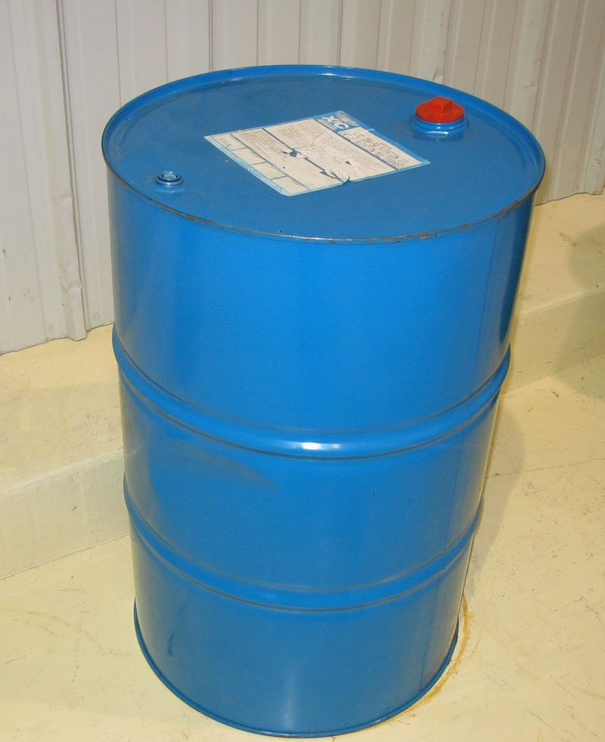
Related Topics:

Resources and References
VOSHA/OSHA Standards 29CFR1910
and 1926 for more information. Standards are available at http://osha.gov/law-regs.html

Date: / /

“Hazards of Solvents Tailgate Talk” Sign In Sheet:

Name: Signature:

