Everyday Safety
Tailgate Talks
Cold Weather Precautions
This This Everyday Safety Tailgate Talk was originally published as the January 2016 “Safety
Pins” by Philip E. Spiezio, Safety Officer, Washington County Office of the Safety Officer

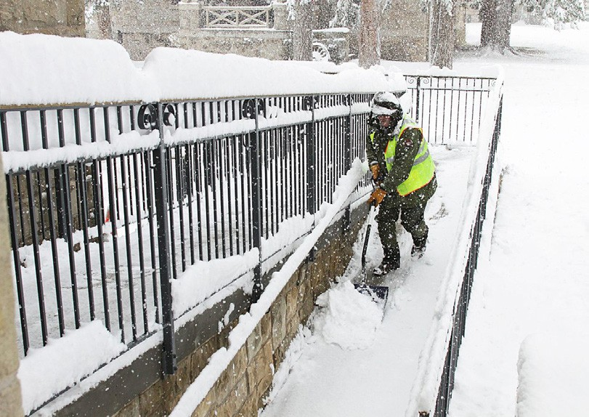
The four environmental conditions that cause cold- related stress are low temperatures, wind, dampness, and cold water. Two or more of these conditions together can make working outdoors very dangerous.

Here are a few tips to keep in mind when working outdoors
in cold weather:

- Wear appropriate protective clothing—Dress in
layers
- When working outside in the winter it is very important that you dress appropriately. When dressing for outside work, think of the THREE W’s when building your layers, WICKING, WARMING and WEATHER.
The first layer should be a WICKING Layer that will draw moisture away from your body. Use synthetic base layers with a wicking apparel to draw sweat away from your body.
The second layer should be a WARMING Layer. This layer should be your insulation. Select wool, fleece or multiple flannel shirts to insulate yourself from the cold and trap air that will be warmed by your body heat. You can then remove pieces of the warming layer as needed.
The third layer should be your WEATHER Layer. Select a garment that will provide additional warmth and protect you from the snow, rain and wind. The Weather Layer should not absorb moisture.
Pay special attention to protecting your feet, hands, face and head. Up to 40 percent of your body heat can be lost when your head is not protected properly.
- Eat high calorie foods and drink liquids that do not contain caffeine or alcohol when working outside in cold temperatures. Proper hydration is a must. Even though it is cold continue to hydrate and drink plenty of water.

- Take frequent short breaks, avoid exhaustion or fatigue as energy is needed to keep your
body warm as well.
- When possible, work during the warmest part of the day.
- Work in pairs, when the weather is very cold and windy.
- Seek warmth when you first start to feel the early signs of your body getting cold.
- Keep in mind that even at 10 degrees with a wind speed of twenty miles per hour— exposed skin can freeze in as little time as 1 minute.

Everyday Safety Tailgate Talks are published by the Cornell Local Roads Program in cooperation with the National Local Technical Assistance Association and participating partner organizations.

Resources and References:
American Red Cross Top Ten Cold Weather Safety Tips http://www.redcross.org/news/article/Top-Ten-Red-Cross-Cold-Weather-Safety-Tips
National Weather Service “Prepare for Cold Weather” Webpage URL http://www.nws.noaa.gov/os/cold/before.shtml
OSHA Cold Stress Guide
https://www.osha.gov/SLTC/emergencypreparedness/guides/cold.html

Date: / /

“Cold Weather Precautions” Sign In Sheet:

Name: Signature:

